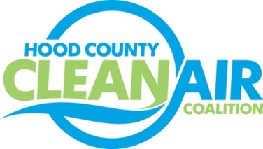
Meeting: Tuesday, October 7, 2014
American Town Hall
220 N. Travis Street, Granbury, Texas 76048
8:30-9:30 a.m.

Agenda

- Call Meeting to Order
- EPA Updates – Carrie Paige
- Regional Updates – Michelle McKenzie
  - Funding Opportunities
    - Emission Reduction Incentive Grant (ERIG) www.terpgrants.org
    - Light-Duty Motor Vehicle Purchase or Lease Incentive Program www.terpgrants.org
    - Texas Clean School Bus Program www.tceq.state.tx.us/p2/clean-vehicles/school-buses.html#grant
  - Clean Fleet Policy Reminder www.nctcog.org/fleetpolicy
  - Clean Cities Update www.dfwcleancities.org
  - Ozone Advance/ Nonattainment Area Meeting
- Local updates – Michelle McKenzie
  - Renewal of TCEQ Contract for Monitor Location
  - Ozone Season Update
  - Conference Call Reports
    - Air North Texas
    - CenSara
  - Rider 8
    - Expense Approval Process
    - Status and Review of Projects
      - Monthly Budget Review
      - City Policy for Degree: Impact on Salary
      - Rental Update
    - Contracts for Technical Projects, Outreach Survey, Website
    - Consider Transfer of Coalition Funds from Lake Granbury EDC to Granbury Administration
- Discussion
- Adjourn

